**Formative Assignment __**

|  |  |
| --- | --- |
| Module Name | Web Development Using Platforms |
| Course Name | Bachelor’s Degree in Software Engineering |
| Assignment Title | Create Sites Using Portlets and Pages |

|  |  |
| --- | --- |
| Learner Name | Francis Roel L. Abarca |

|  |
| --- |
| Learner declaration |
| I certify that the work submitted for this assignment is my own and research sources are fully acknowledged.  Student signature: Date: 3/28/23 |

**Trainer--- University training, SSG training,**

**Content development**

**Scope of this assignment**

1. Setup the Liferay IDE development environment as follows:

* Download the Liferay Developer Studio IDE.
* Launch Liferay Developer Studio and specify your Liferay Workspace Directory
* Create a new Liferay server from the Server Tab.
* Choose Liferay 7.x Server from Liferay, Inc.
* Specify the installation directory of the Tomcat configured with Liferay Select runtime JRE (prefer JDK is 11)
* Click finish Start the Tomcat server, and Access the Liferay home via http://localhost:8080/
* And, create a site using pages and portlets as below.

1. Create Feedback MVC Portlet Provide the sample demonstration are as follows:

* Create a new Liferay plugin project with a project name "NewsPortalFeedback".
* Create Liferay MVC portlet (FeedbackPortlet)
* Create new JSP (feedback.jsp) then simply create actionURLs and Feedback Form to submit the feedback.
* Create a controller (a portlet action) method to handle the Feedback form. You need to specify the portlet class action as the URL name attribute. What this action method does is grab the form’s input date then prints it in the Console.
* In view.jsp, add the "Add New Feedback" link by using render URL tag. When the user clicks the link, the "Feedback form" appears.
* Deploy the portlet. Enable and test the portlet.

**Task Wise Solutions**

**Setup the Liferay IDE development environment**

* **Download Liferay Developer Studio IDE.**

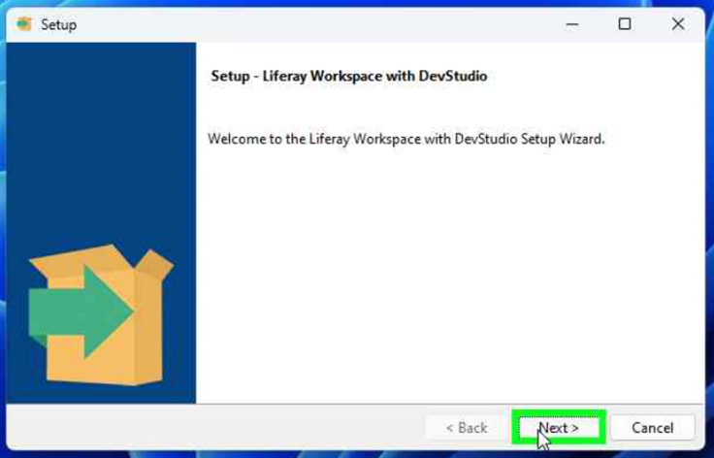

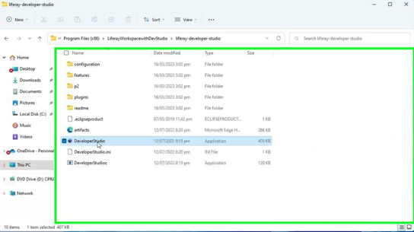

* **Launch Liferay Developer Studio then specify your Liferay Workspace Directory**

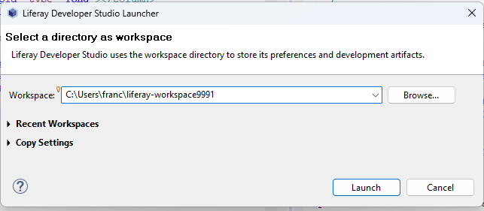

* **Define new server from Server Tab and Choose Liferay 7.x Server from Liferay, Inc.**

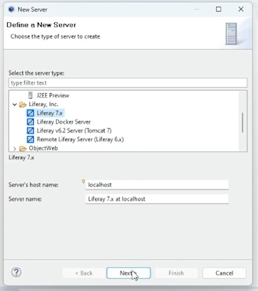

* **Specify the installation directory of the Tomcat configured with Liferay Select runtime JRE (prefer JDK is 11)**

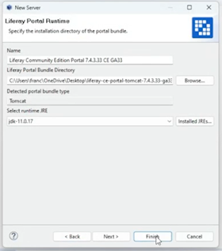

* **Click finish Start the Tomcat server, and Access the Liferay home via** [**http://localhost:8080/**](http://localhost:8080/)

* **And, create a site using pages and portlets as below.**

**Create Feedback MVC Portlet.   
Provide the sample demonstration are as follows:**

* **Create a new Liferay plugin project with a project name "NewsPortalFeedback".**

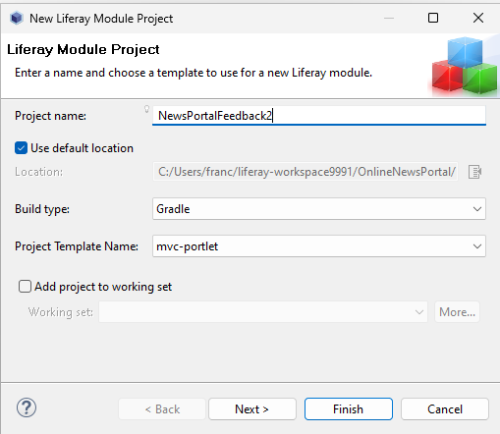

* **Create Liferay MVC portlet (FeedbackPortlet)**
* **Create new JSP (feedback.jsp) then simply create actionURLs and Feedback Form to submit the feedback.**

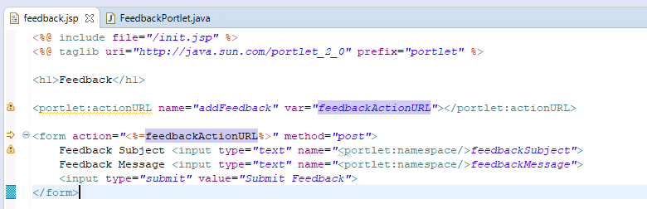

* **Create a controller (a portlet action) method to handle the Feedback form. You need to specify the portlet class action as the URL name attribute. What this action method does is grab the form’s input date then prints it in the Console.**

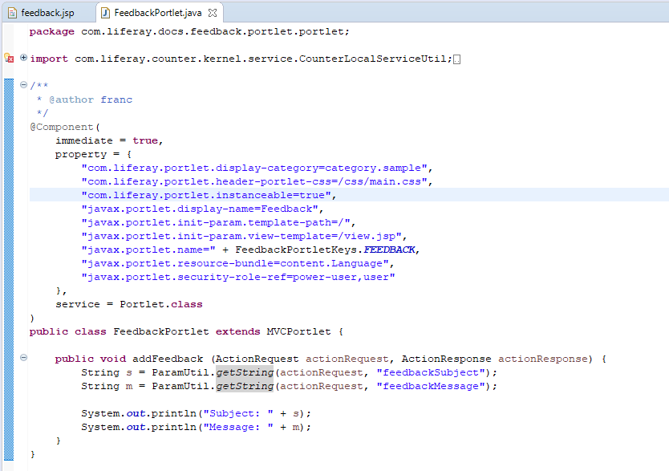

* **Inside view.jsp, add the href for your feedbackRenderURL so that the page will load the feedback.jsp items to the site.**

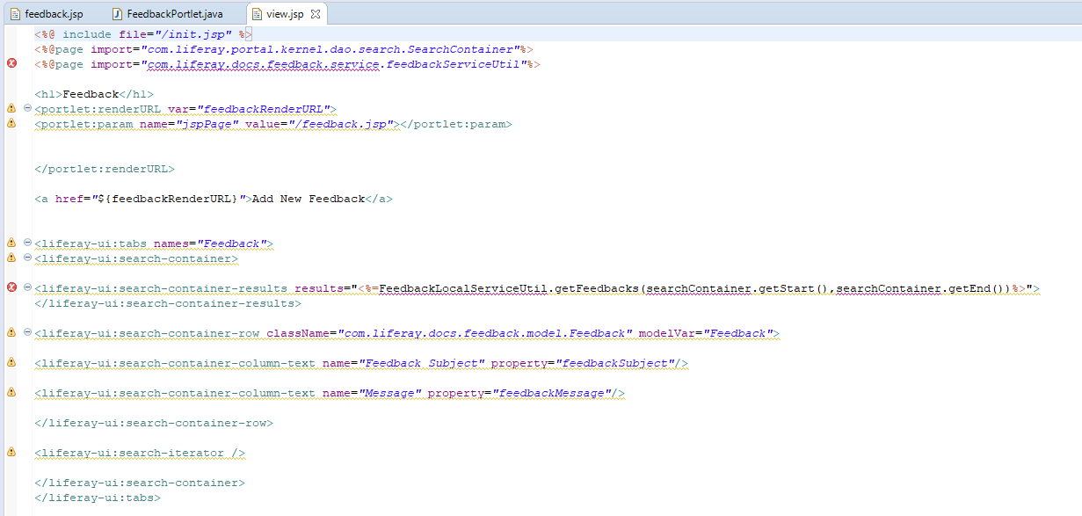

* **Implement the portlet onto your site then test it out.**

